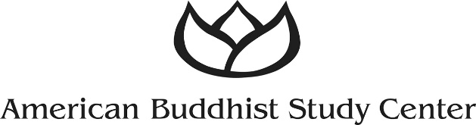

NEWS RELEASE

FOR IMMEDIATE RELEASE

American Buddhist Study Center Hosts Father and Son Exhibit Titled “Pure Awakening”

New York, NY—Sept. 24, 2019— On exhibit from Oct. 19-Nov. 10 in the American Buddhist Study Center library, located on the third floor of the New York Buddhist Church at 331 Riverside Drive in New York City, will be works of art spanning two generations that feature paintings and drawings by the late Howard Horii and his son, Ken Horii.

Both accomplished artists, this father and son exhibit is titled “Pure Awakening” and illustrates how experience in the world can be processed through the act of drawing, and how the creative process itself can influence and be passed on to the next generation, according to Hoshina Seki, president of the center.

“We’re excited about hosting this exhibition,” Hoshina said, “Howard Horii’s art is pictorial, and includes historic portrayals of WWII Japanese American internment camps, while Ken Horii’s work is represented in contemporary, abstract diagrams, seamlessly taking us into the future. From a Buddhist perspective, it demonstrates the interconnectedness of all beings.”

A former Pratt Institute instructor and an award-winning architect, Howard spent three years in his youth in a Japanese American internment camp in Arizona during the war. He made sketches of his observations during that time period, and later turned those sketches into watercolors. His son Ken exhibits both nationally and internationally, and is a professor of Spatial Dynamics at the Rhode Island School of Design.

The exhibit opening will be held from 2:30-5:30 p.m. on Oct. 19, with a gallery talk by Ken Horii at 2:30 p.m. The exhibit closing will be held from 2-4 p.m. on Nov. 10, with a gallery talk by Ken at 2 p.m. On weekends in between those dates the exhibit can be seen from noon-5 p.m., and on weekdays by appointment, 212-864-7424.

# # #

American Buddhist Study Center Contact:
Hoshina Seki
hoshinazen@gmail.com
212-864-7424

Media Contact:
Paula Horii
Cardinal Public Relations
paulahorii@gmail.com
908-578-4479

